**College Hall Not Interpolated Old Data**

Learning Regression Tree...

Elapsed time is 0.316586 seconds.

Training RMSE(W): 3.67, R2: 0.930, RMSE/peak: 0.0331, NRMSD: 3.97

Learning a cross validated tree...

Elapsed time is 2.787507 seconds.

Cross Validated Training RMSE(W): 5.45, R2: 0.847, RMSE/peak 0.0491, NRMSD: 5.89

Learning a Random Forest...

Elapsed time is 103.697728 seconds.

Random Forests Training RMSE(W): 4.04, R2: 0.916, RMSE/peak 0.0364, NRMSD: 4.36

Testing RMSE(W): 9.78, R2: 0.521, RMSE/peak: 0.0923, NRMSD: 15.40

Cross Validated Testing RMSE(W): 8.11, R2: 0.671, RMSE/peak 0.0765, NRMSD: 12.76

RF (Testing) RMSE(W): 7.24, R2: 0.738, RMSE/peak 0.0683, NRMSD: 11.39

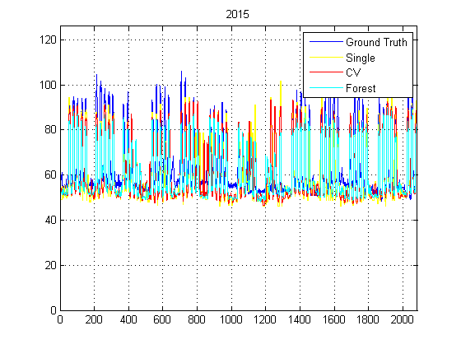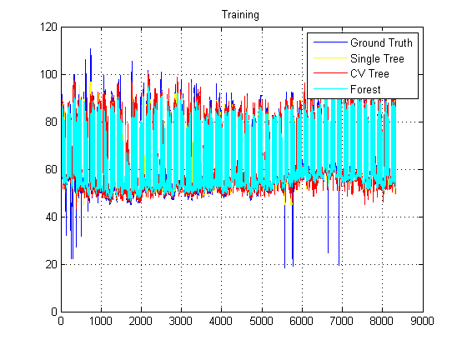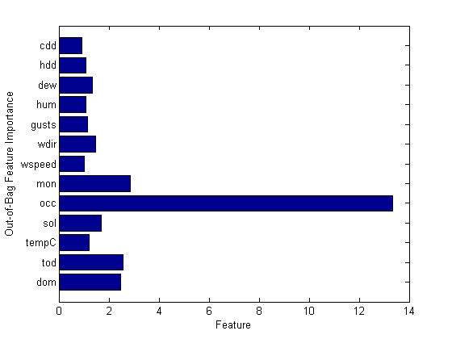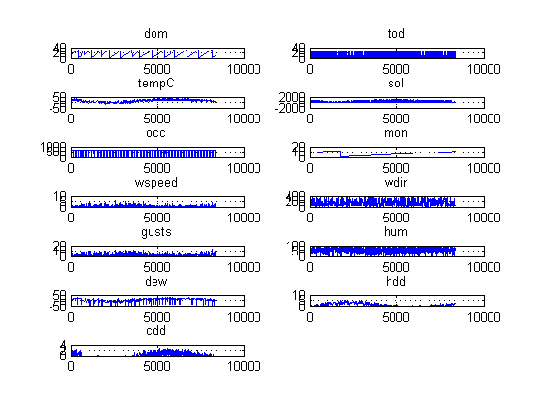

**College Hall Interpolated Old Data**

Learning Regression Tree...

Elapsed time is 0.368547 seconds.

Training RMSE(W): 4.21, R2: 0.916, RMSE/peak: 0.0379, NRMSD: 4.55

Learning a cross validated tree...

Elapsed time is 2.962583 seconds.

Cross Validated Training RMSE(W): 5.80, R2: 0.841, RMSE/peak 0.0523, NRMSD: 6.27

Learning a Random Forest...

Elapsed time is 105.675763 seconds.

Random Forests Training RMSE(W): 4.69, R2: 0.896, RMSE/peak 0.0423, NRMSD: 5.07

Testing RMSE(W): 8.99, R2: 0.597, RMSE/peak: 0.0849, NRMSD: 14.11

Cross Validated Testing RMSE(W): 7.61, R2: 0.711, RMSE/peak 0.0719, NRMSD: 11.95

RF (Testing) RMSE(W): 7.23, R2: 0.740, RMSE/peak 0.0682, NRMSD: 11.35

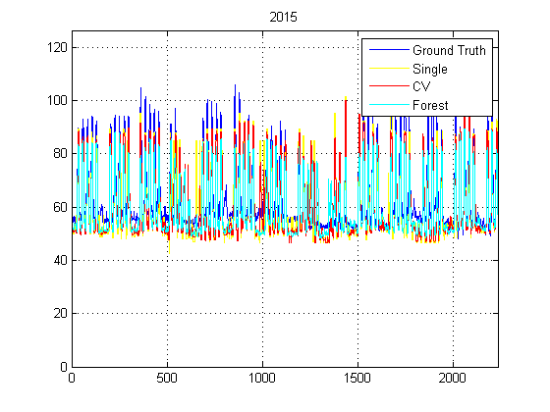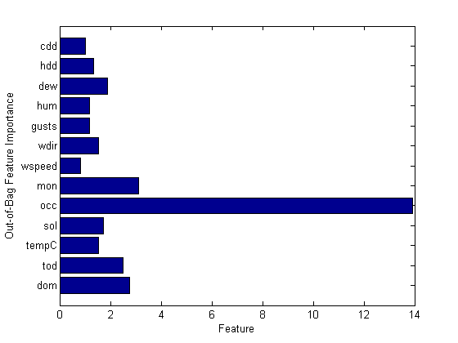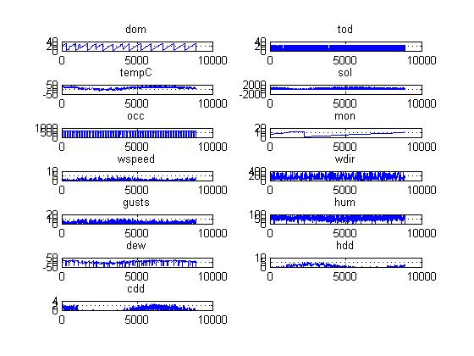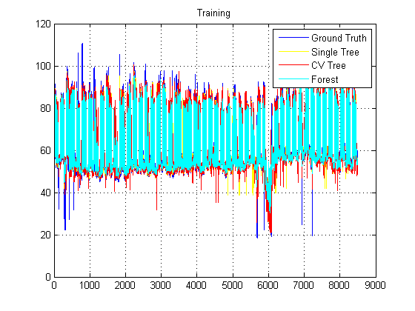

**College Hall Interpolated New Data**

Learning Regression Tree...

Elapsed time is 0.426536 seconds.

Training RMSE(W): 6.96, R2: 0.940, RMSE/peak: 0.0325, NRMSD: 3.98

Learning a cross validated tree...

Elapsed time is 3.703593 seconds.

Cross Validated Training RMSE(W): 9.93, R2: 0.878, RMSE/peak 0.0464, NRMSD: 5.68

Learning a Random Forest...

Elapsed time is 127.394876 seconds.

Random Forests Training RMSE(W): 7.90, R2: 0.923, RMSE/peak 0.0369, NRMSD: 4.51

Testing RMSE(W): 16.11, R2: 0.704, RMSE/peak: 0.0757, NRMSD: 12.38

Cross Validated Testing RMSE(W): 14.19, R2: 0.770, RMSE/peak 0.0666, NRMSD: 10.90

RF (Testing) RMSE(W): 13.36, R2: 0.796, RMSE/peak 0.0628, NRMSD: 10.27

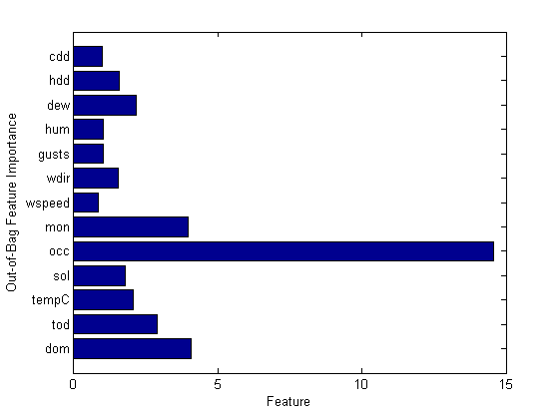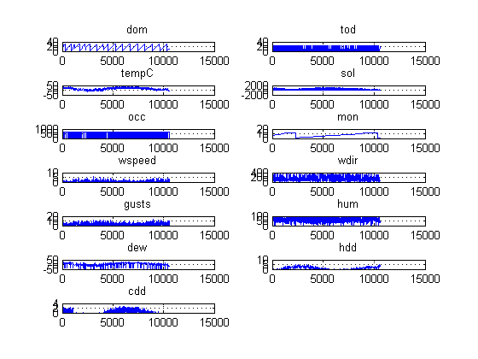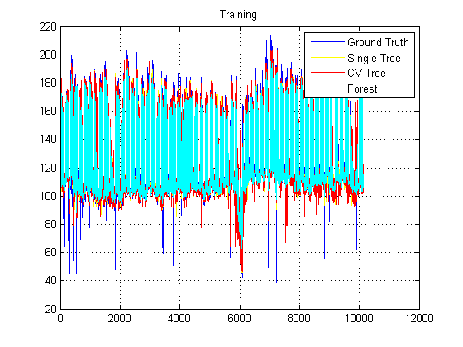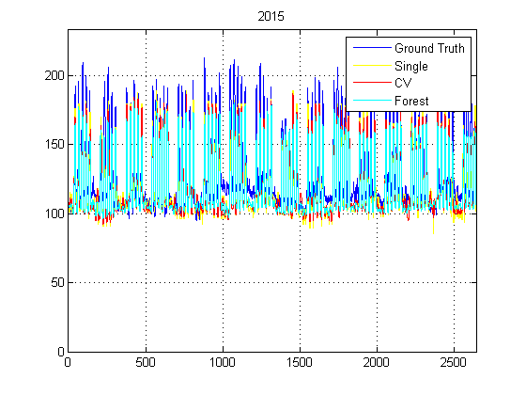

**College Hall Not Interpolated New Data**

Learning Regression Tree...

Elapsed time is 0.386526 seconds.

Training RMSE(W): 6.56, R2: 0.943, RMSE/peak: 0.0307, NRMSD: 3.75

Learning a cross validated tree...

Elapsed time is 3.430568 seconds.

Cross Validated Training RMSE(W): 9.32, R2: 0.886, RMSE/peak 0.0436, NRMSD: 5.33

Learning a Random Forest...

Elapsed time is 121.882343 seconds.

Random Forests Training RMSE(W): 6.69, R2: 0.941, RMSE/peak 0.0313, NRMSD: 3.82

Testing RMSE(W): 15.69, R2: 0.714, RMSE/peak: 0.0737, NRMSD: 12.08

Cross Validated Testing RMSE(W): 14.60, R2: 0.752, RMSE/peak 0.0686, NRMSD: 11.24

RF (Testing) RMSE(W): 12.52, R2: 0.818, RMSE/peak 0.0588, NRMSD: 9.64

